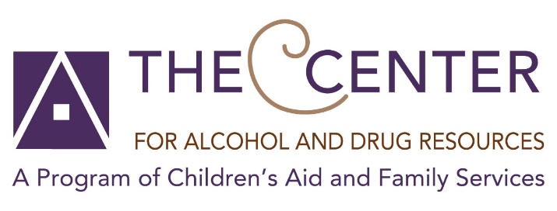

FREE Virtual Recovery Support Programs for residents of Bergen County.
Although the nation’s pandemic has caused us mass isolation and disconnection, your journey though recovery does not have to take a hiatus. The Center for Alcohol and Drug Resources is still here to support you! We are hosting free virtual meetings to assist you and your loved ones during this stressful time. You are invited to join in to any of the meetings below to connect with you and your family through the journey of recovery.
Mondays

Reflections in Recovery
Host: Chrissy and Rebecca
Time: 11:00am to 12:00pm
Zoom: https://zoom.us/j/593678446 or Call In: {646) 558-8656
Meeting ID: 593 678 446
Password: 009678
An open forum to help with keeping an attitude of gratitude, hope, and living one day at a time, patience and tolerance, learning how to plan for the action not the result. We will share ideas and discuss how to sustain a healthy, happy and sober life.

Managing Anxiety
Host: Helena and Maria
Time: 2:00pm to 3:00pm
Zoom: https://zoom.us/j/97968636011 or Call In: (646) 558-8656
Meeting ID: 979 6863 6011
A group designated to expressing our feelings of anxiety and how we can cope with them.

Tuesdays

Meditation
Host: John Paul
Time: 12:30pm to 1:30pm
Zoom: https://zoom.us/j/92964961138 or Call In: (929) 205-6099
Meeting ID: 929 6496 1138
Practice the art of mindfulness to achieve mental clarity, and emotional calm by releasing stress and anxiety.

Wednesdays

Alone Together
Host: Carmen and Shyra
Time: 10:00am to 11:00am
Zoom: https://zoom.us/j/99191294035 or Call In: (646) 558-8656
Meeting ID: 991 9129 4035
Password: 879819
For anyone in the recovery field to assist with helping to manage your clients, out-sourcing resources and
practicing self-care.

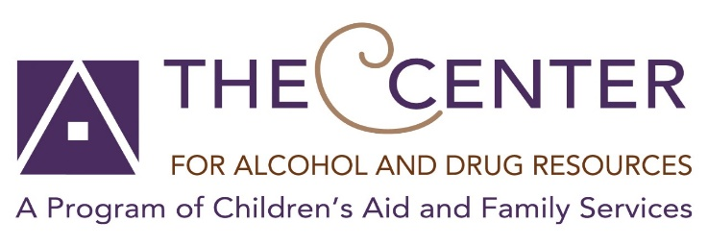

Wednesdays

Compassionate Nonviolent Communication: The Language of Life
Host: John Paul
Time: 7:00pm to 9:00pm
Zoom: https://zoom.us/j/682665045 or Call In: (929) 205-6099
Meeting ID: 682 665 045
We learn about empathy and how to communicate with others compassionately and without judgement.

Thursdays

Recovery Support Meeting
Host: Christine and Alex
Time: 2:00pm to 3:00pm
Zoom: https://zoom.us/j/99104451682 or Call In: (646) 558-8656
Meeting ID: 654 066 402
Password: 421080
For anyone in the recovery field to assist with helping to manage your clients, out-sourcing resources and practicing self-care.

CRAFT Group for loved ones
Host: Chanel
Time: 6:00pm to 7pm
Zoom: https://zoom.us/j/891110613 or Call In: (646) 558-8656
Meeting ID: 891 110 613
Learn skills to build better communicate with “Loved Ones” with an addiction and practice self-care.

Fridays

LGBTQ Plus Recovery
Host: Elaine
Time: 6:00pm to 7:00pm
Zoom: https://us04web.zoom.us/j/967823782348 or Call In: (646) 558-8656
Meeting ID: 967 782 348
This is a safe and non-judgmental meeting for members of the LGBTQ+ community in recovery from active
addiction and/or substance use disorders. This meeting is in NO way connected to any “12 step” fellowship and will
be used as a resource devoted to open sharing, topic discussions and establishing community.

FOR MORE INFORMATION, PLEASE CALL

201-740-7030

