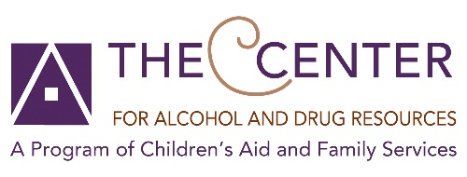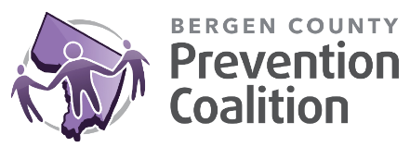

**National Recovery Month Campaign Toolkit- 2025**

Thank you for downloading this campaign. This toolkit includes the post order, language, images, and hashtags. We would love it if you tagged us in the posts so we can engage with you! In addition to social media, community events are listed below.

**Tag Us**

|  |  |  |
| --- | --- | --- |
| Social Media Platform | TCADR | Bergen County Prevention Coalition |
| Facebook | @TCADR | @BergenCountyPreventionCoalition |
| Instagram | @TCADR_NJ | @BCPC_NJ |

**What is Recovery Month?**  
Since 1989, Recovery Month is observed every September to celebrate the gains made by those in recovery from substance use disorder. The month also promotes and supports new treatment and recovery practices, the nation's strong and proud recovery community, and the dedication of service providers and communities who make recovery in all its forms possible. The year's theme, "Recovery is REAL (Restoring Every Aspect of Life)", emphasizes that with the right treatment, support, and resources, recovery is possible.

**Hashtags:** #RecoveryMonth2025 #RecoveryJourney #RecoveryIsForEveryone #RecoveryIsPossible #RecoveryIsREAL

**Posts**

Included here are 2 posts per week.

|  |  |  |
| --- | --- | --- |
| **Week, Day** | **Image Description** | **Post** |
| Week 1, Day 1 | Recovery starts with caring for your whole self | #RecoveryMonth2025 is a great time to prioritize care, connection, and healing. ❤️‍Need help getting started? #Recovery #Wellness |
| Week 1, Day 2 | Recovery is a way to care for yourself every day | During #RecoveryMonth2025, focus on your well-being. Sleep 🛏️, healthy eating 🍅, exercise 🏃‍➡️and connections 💞 are vital. |
| Week 2, Day 1 | Recovery is the foundation for a healthy and happy home. | DYK: 50.2 million American adults consider themselves in recovery? Recovery is REAL and starts in spaces that heal. #RecoveryMonth2025 #YouAreNotAlone |
| Week 2, Day 2 | Recovery is a Family Affair | #RecoveryHappens in a stable home. During #RecoveryMonth2025 and beyond, let’s help create spaces where people feel safe, respected, and supported. |
| Week 3, Day 1 | Be the voice of Recovery | #RecoveryHappens. The journey can be easier with the right people by your side. |
| Week 3, Day 2 | A strong recovery network starts with one word | You don’t have to be alone in #Recovery. Find your support network. Find your strength. Explore options that work for YOU at samhsa.gov/recovery #RecoveryMonth2025 #YouAreNotAlone |
| Week 4, Day 1 | Fuel your recovery with things that give your life meaning and joy | Doing things that lift you up makes #Recovery REAL (Restores Every Aspect of Life). 🌟💡😀 Do you know the guiding principles of recovery? Find them at samhsa.gov/find-help/recovery #RecoveryMonth2025 |
| Week 4, Day 2 | You matter to the people in your life | 💌 This is a reminder that you are important. Helping a neighbor, sharing an activity, simply showing up for someone not only helps them , it also helps YOUR #Recovery #RecoveryHappens #RecoveryMonth2025 |

**Community Actions**

* Host a Naloxone, also known as Narcan, training for your community
  + Narcan is a powerful opioid antagonist that works to reduce the effects of an opioid overdose.
  + Narcan is an easy to administer nasal spray.
  + The Center for Alcohol and Drug Resources offers Narcan trainings to individuals and communities. The trainings include a brief overview of the opioid crisis in New Jersey, and each participant receives Narcan to take home with them. Contact [jfernandez@cafsnj.org](mailto:jfernandez@cafsnj.org) to schedule!
* Advocate for your community to pass a resolution to increase access to Naloxone
  + As of August 2025, 8 Bergen County towns have passed resolutions. Each has vowed to place Narcan in all public AED locations in town
  + Interested in one for your town? Email [ccolaizzi@cafsnj.org](mailto:ccolaizzi@cafsnj.org) for sample resolutions

**Continue the momentum!**

* Knock Out Opioid Abuse Day is October 6th
  + TCADR is encouraging towns to adopt proclamation recognizing the importance of the day
  + Email [ccolaizzi@cafsnj.org](mailto:ccolaizzi@cafsnj.org) for a draft copy
* Red Ribbon Week is October 23-31st
  + BCPC is encouraging towns to Light It Up Red!
    - Adding red bows to trees and poles in town to increase visibility and/or
    - Changing outdoor lighting to red bulbs to remind people about Red Ribbon Week
  + More Red Ribbon Week ideas can be found here: [Red Ribbon Campaign | Largest drug-use prevention campaign in the U.S.](https://www.redribbon.org/)